**Testing Strategy**

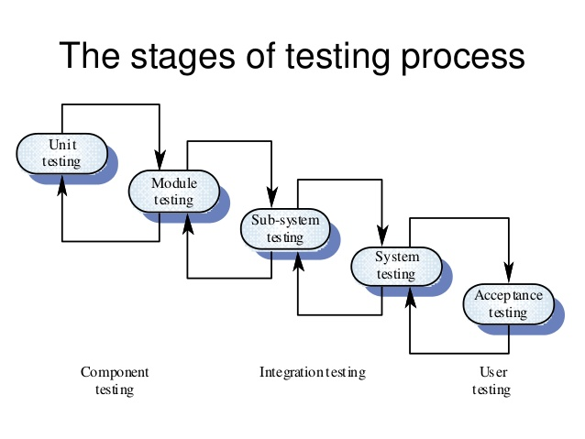

The testing strategy is used to identify the levels of testing which are to be applied along with the methods, techniques, and tools to be used during testing. This strategy also decides test cases, test specifications, test case decisions, and puts them together for execution.

Developing a test strategy, which efficiently meets the requirements of an organization, is critical to the success of software development in that organization. Therefore, a software testing strategy should contain complete information about the procedure to perform testing and the purpose and requirements of testing.

Our testing strategy has the following characteristics:

1. Testing proceeds in an outward manner. It starts from testing the individual units, progresses to integrating these units, and finally, moves to system testing.
2. Testing is conducted by the software developer and by an ITG(Independent Test Group - A group of people whose primary responsibility is software testing).
3. Brute force testing done by Software Developer before sending the system to the testing engineer/department.
4. Brute force approach(i.e., initially manual testing) done by testing engineer.This is followed by testing with the help of testing tools(by writing test cases).Testing tool used currently : Selenium
5. Final testing done by Product Manager before deployment into the real world.

Workflow is as follows:

Staging Phase 🡪 Production phase 🡪 Deployment phase

Amalgamation of the following strategies will also be used in our strategy:

1. **Analytic testing strategy:** This uses formal and informal techniques to access and prioritize risks that arise during software testing. It takes a complete overview of requirements, design, and implementation of objects to determine the motive of testing. In addition, it gathers complete [information](https://ecomputernotes.com/fundamental/information-technology/what-do-you-mean-by-data-and-information) about the software, targets to be achieved, and the data required for testing the software.
2. **Model-based testing strategy:** This strategy tests the functionality of the software according to the real world scenario (like software functioning in an organization). It recognizes the domain of data and selects suitable test cases according to the probability of errors in that domain.
3. **Dynamic testing strategy:** This tests the software after having a collective decision of the testing team. Along with testing, this strategy provides information about the software such as test cases used for testing the errors present in it.
4. **Philosophical testing strategy:** It tests the software assuming that any component of the software can stop functioning anytime. It takes help from software developers, users and systems analysts to test the software.

**Inputs:**

1. Type of development project
2. Complete information about the hardware and software components that are required to develop the software
3. Risks involved
4. Description of the resources that are required for testing
5. Description of all testing methods that are required to test various phases of SDLC
6. Details of all the attributes that the software is unable to provide.

**Outputs:**

1. In addition to detecting errors, a good testing strategy should also assess portability and usability of the software.
2. It should use quantifiable manner to specify software requirements such as outputs expected from software, test effectiveness, and mean time to failure which should be clearly stated in the test plan.
3. It should improve testing method continuously to make it more effective.
4. Test plans that support rapid cycle testing should be developed. The feedback from rapid cycle testing can be used to control the corresponding strategies.
5. It should conduct formal technical reviews to evaluate the test cases and test strategy. The formal technical reviews can detect errors and inconsistencies present in the testing process.

Test Review 1 comments:

Create Calendar page

Current Model Accuracy – 93% (try to increase)

Strengthen credentials (can be done in the last stage – finishing touches)

Contact Us “Send” button requires redirection

“Forgot Password” requires redirection

Test Review 2 comments:

Calendar page created

Model Accuracy increased to 99.7%

After discussion with developers - Strengthen credentials (can be done in the last stage – finishing touches)

Contact Us “Send” button requires redirection (finishing touches)

“Forgot Password” requires redirection (finishing touches)

**End of Sprint 1**